8.89: The “missing momentum” is

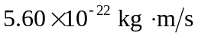 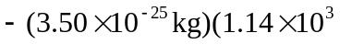 m/s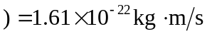 .

Since the electron has momentum to the right, the neutrino’s momentum must be to the left.

